Assignment 1

Name : Shafiqur Rajib Eram

Roll : 20230108016

Department : ME

Year : 1st

Semester : 2nd

Group : A1

1. Write a program to determine the LCM (least common multiple) and GCD (Greatest common divisor) of 3 numbers.

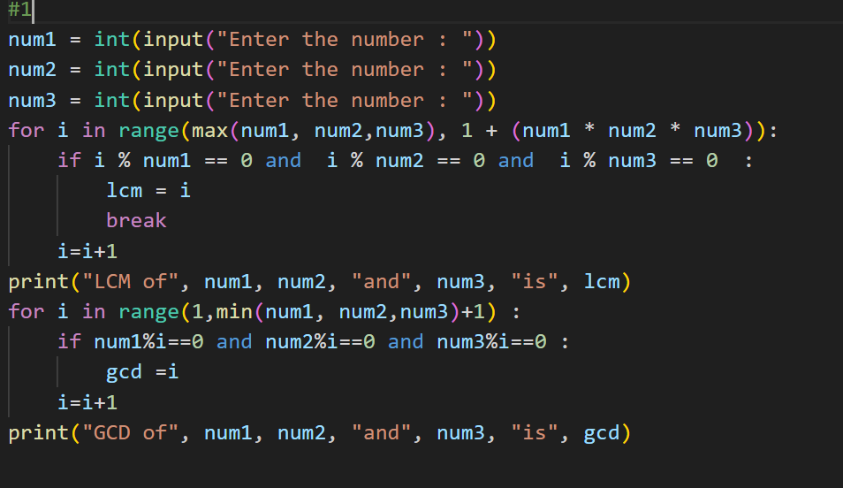

2. Find out the sum of each of the following series. n is the input from user for series:

1. 1 + ( 1 + 2 ) + ( 1 + 2 + 3 ) + … + ( 1 + 2 + 3 + … + n )

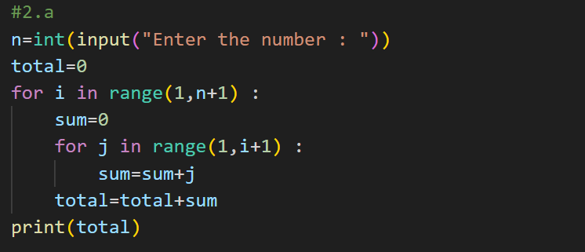

1. 5 – 11 + 17 - … (up to n th term )

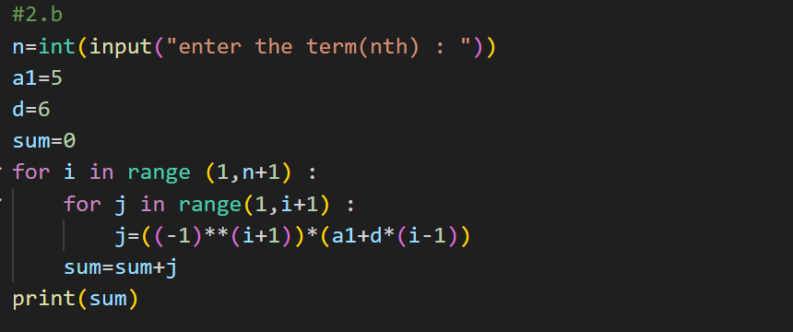

3. Write a program to determine all prime numbers within the range [a …b] where a & b are input through the keyboard.

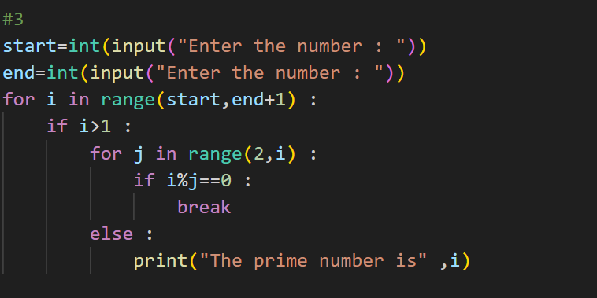

4. Input two numbers from the keyboard. Write a program to find the value of one number raised to the power of another.

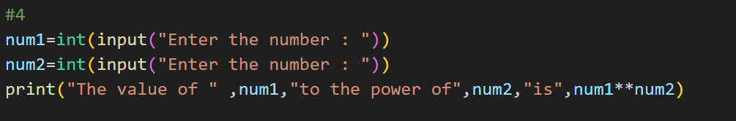

5. 145 is a special number, since it satisfies the following relation: 145 = 1! + 4! + 5! = 1+24+120 =145 WAP to print all the numbers of this kind between 1 – 1000000.

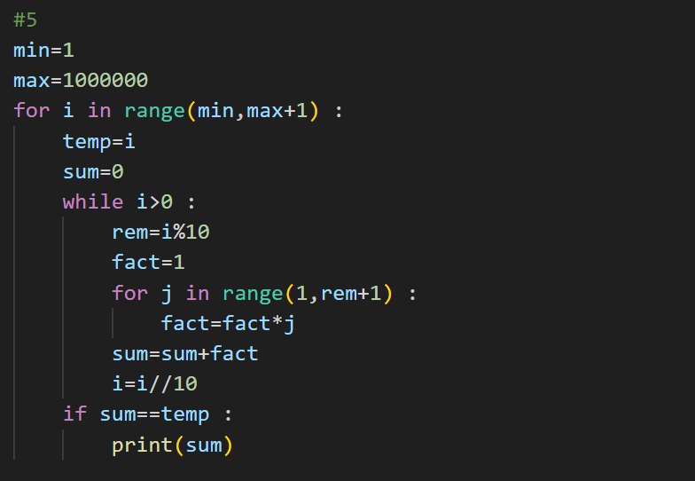

6. WAP to determine all Pythagorean triplets in the range 100 to 1000. (A Pythagorean triplet is a set of three integers i, j, k such that i2 + j2 = k2)

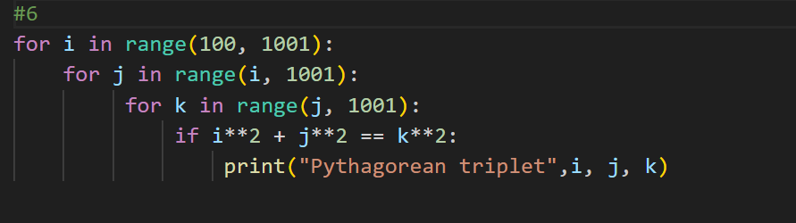

7. Write a program to find the first n Fibonacci number where n is the input from the user.

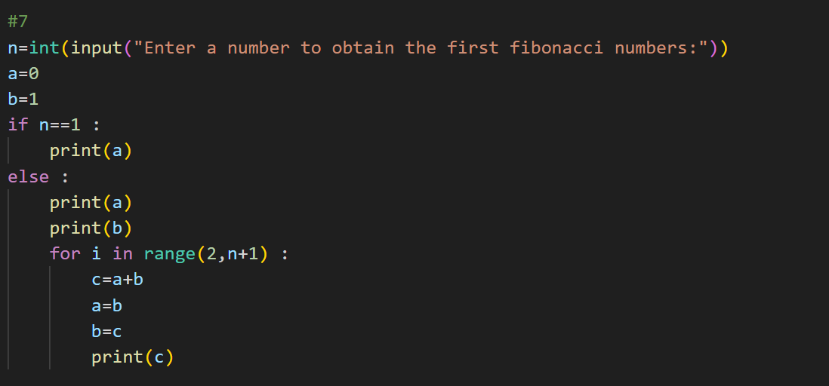

8. Write a program to show the following triangle/rectangle of ‘\*’s or numbers. Take n as input from the user to determine the number of rows of the structure. (eg: n = 5 )

a)

1

1 2 1

1 2 3 2 1

1 2 3 4 3 2 1

1. 2 3 4 5 4 3 2 1

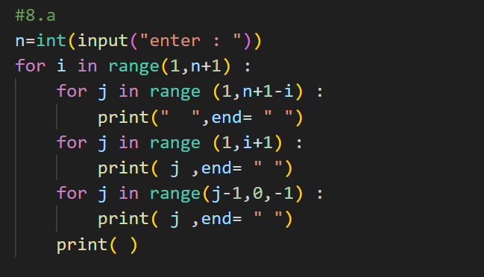

b ) 1

1 2 1

1 2 3 2 1

1 2 3 4 3 2 1

1 2 3 4 5 4 3 2 1

1 2 3 4 3 2 1

1 2 3 2 1

1 2 1

1

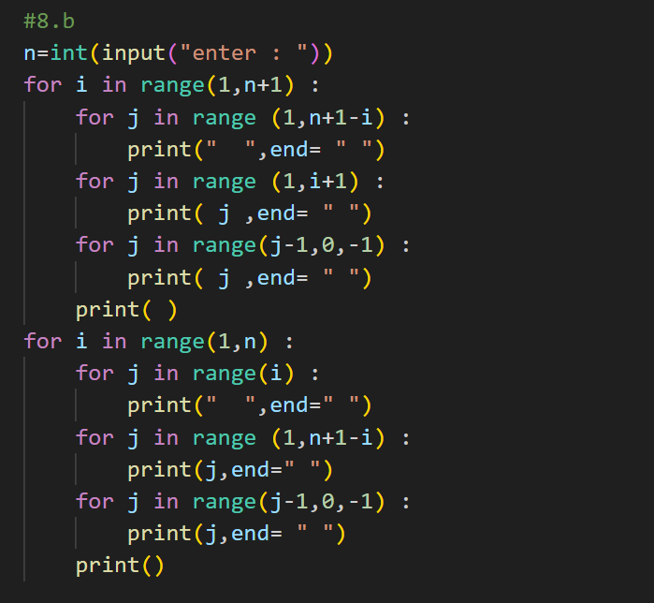

9. Write a code to find out the prime factors of an input number. (Example: Prime factors of 12 are - 2 and 3.)

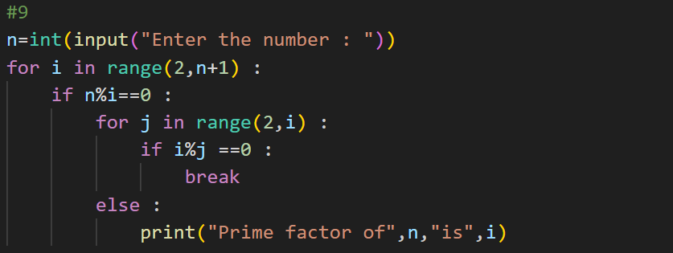

10.Write a program to take input integer numbers until -1 is encountered. If the user inputs an odd number, display it as output. Otherwise, don’t display the number.

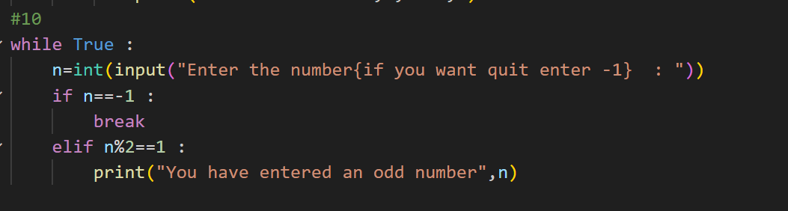

11. Write a program to input a 2 digit number (0-99) and display the number in words. (Example: 78 -> Seventy Eight)

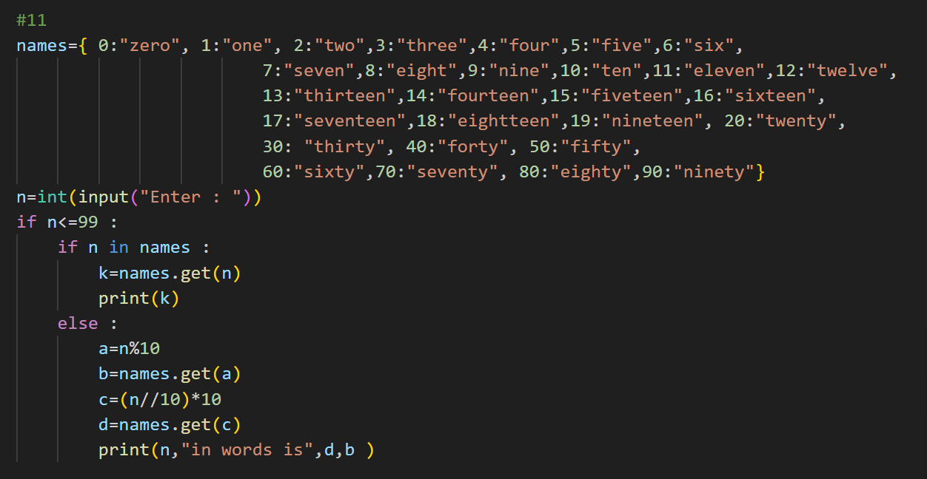

12.Square of 12 is 144. 21, which is a reverse of 12 has a square 441, which is the same as 144 reversed. There are few numbers which have this property. Write a program to find out whether any more such numbers exist in the range of 10 to 500.

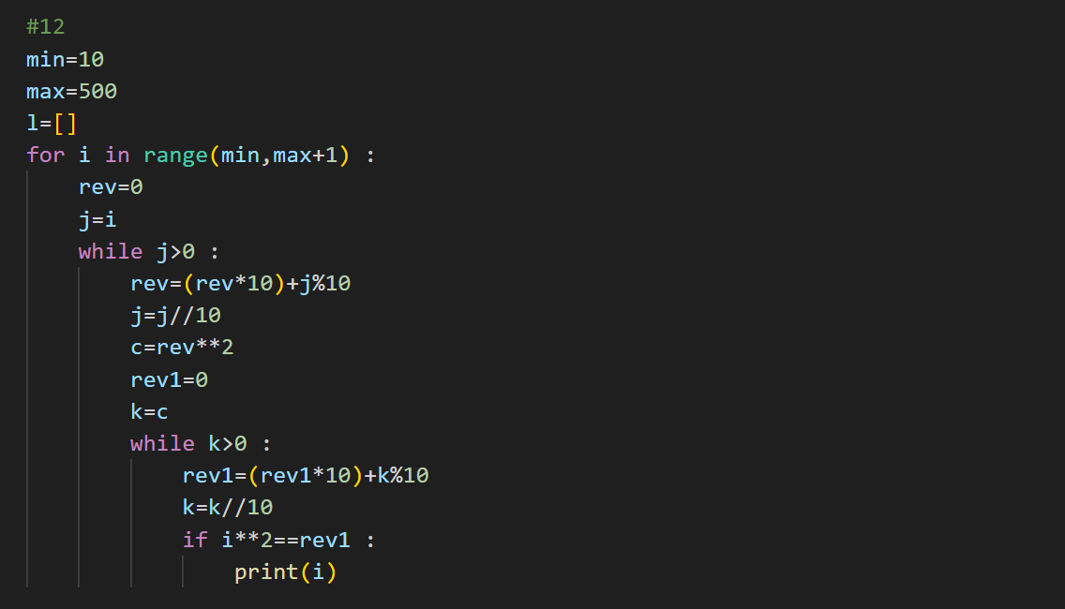

13.WAP to find out the sum of the following series:

a) x – 𝑥 /3! + /5! – /7! + /9! -……. /n!

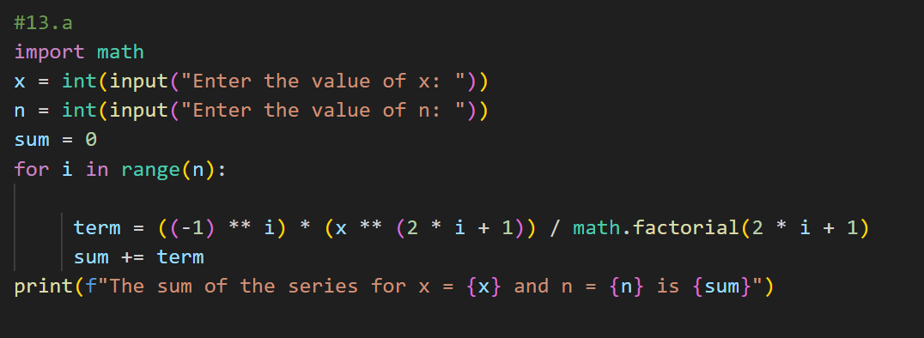

b) (2) + (2+4) + (2+4+6) + (2+4+6+8) …………. up to n terms.

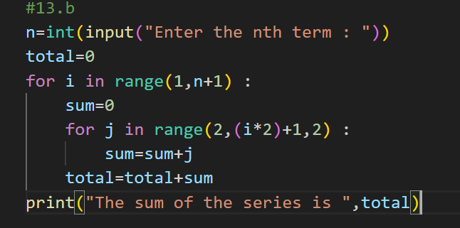

14.Write a program to print out all Armstrong numbers between 1 and 10000. If the sum of cubes of each digit of the number is equal to the number itself, then the number is called an Armstrong number. For example, 153 = (1\*1\*1) + (5\*5\*5) + (3\*3\*3).

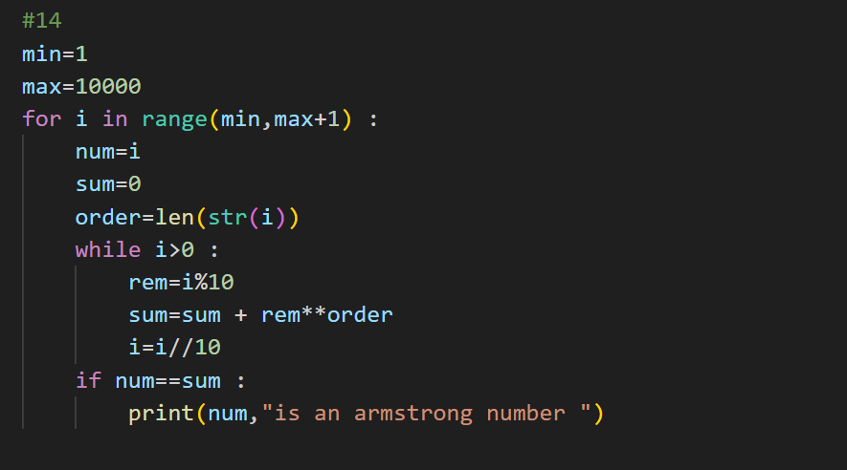

15.WAP to take input three digits and print all the numbers which can be formed using different combinations of these digits. (Input 1 2 0 Output- 12 21 102 120 201 210)

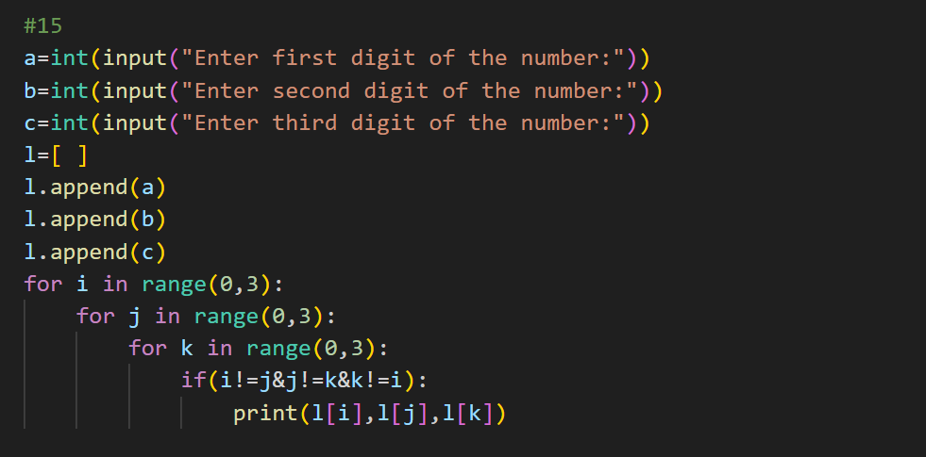

16.Write a program for inserting an element into a position of a list. The element and the insertion point are inputs from the user.

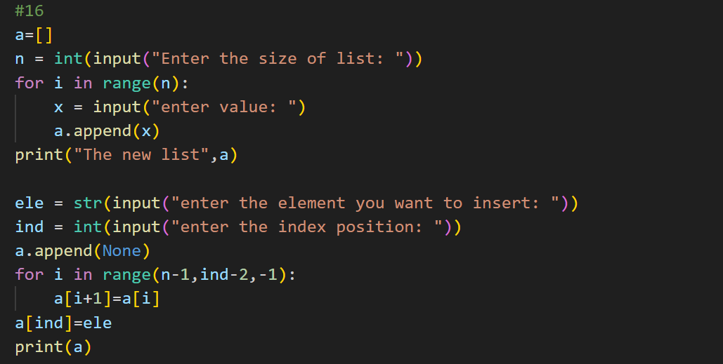

17.Write a program for inserting a number into the proper position of a list which is sorted in ascending order.

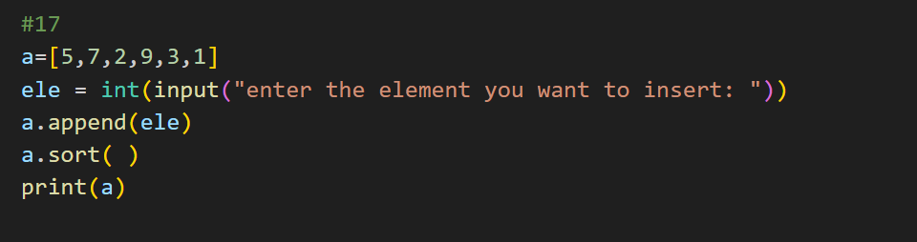

18.Write a program to find k-th maximum and k-th minimum from a list.

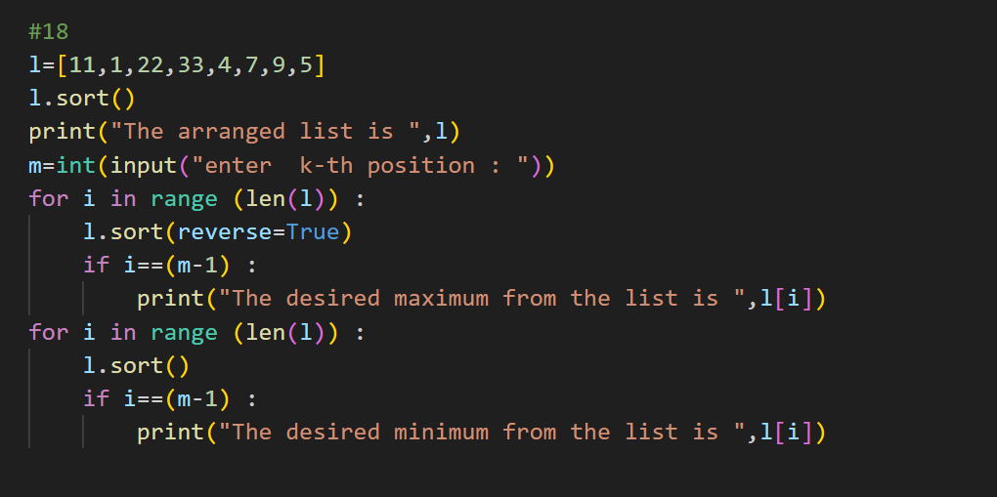

19.Write a program to count the number of letters and words within a text.

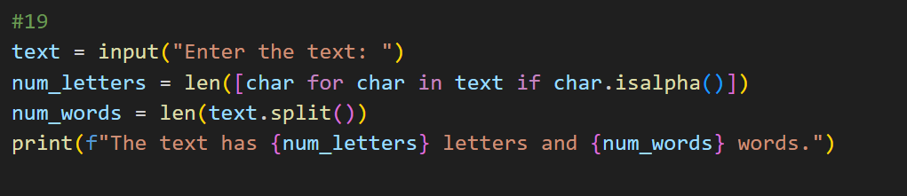

20.Write a program to check whether an input string is palindrome or not.

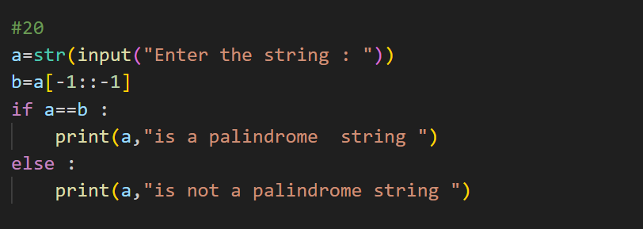

21.Write a program to count the frequencies of each character present in a text. (In addition to alphabet letters, count also the space, tab and punctuation letters)

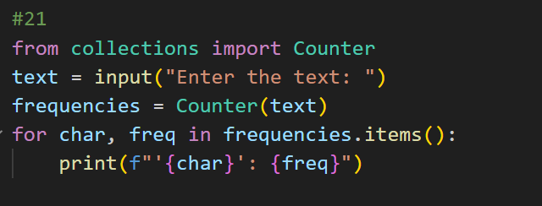

22.Write a program which will search for a substring within a string.

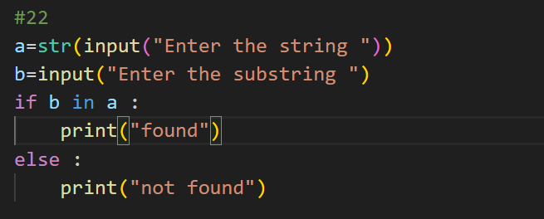

23.Write a program to delete duplicate numbers from a list.

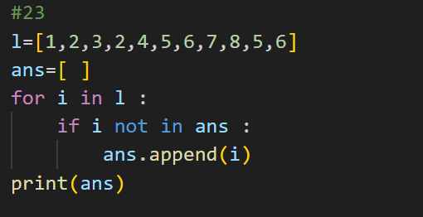

24.Write a program to find the common characters from two lists.

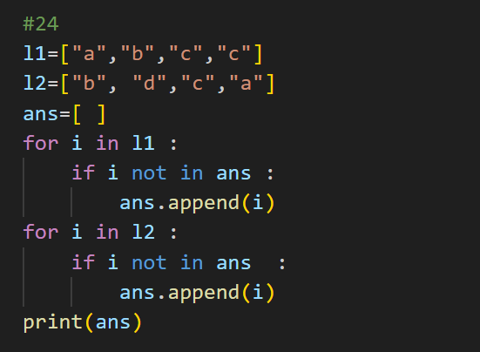

25.Write a program to merge two lists removing the duplicate elements.

